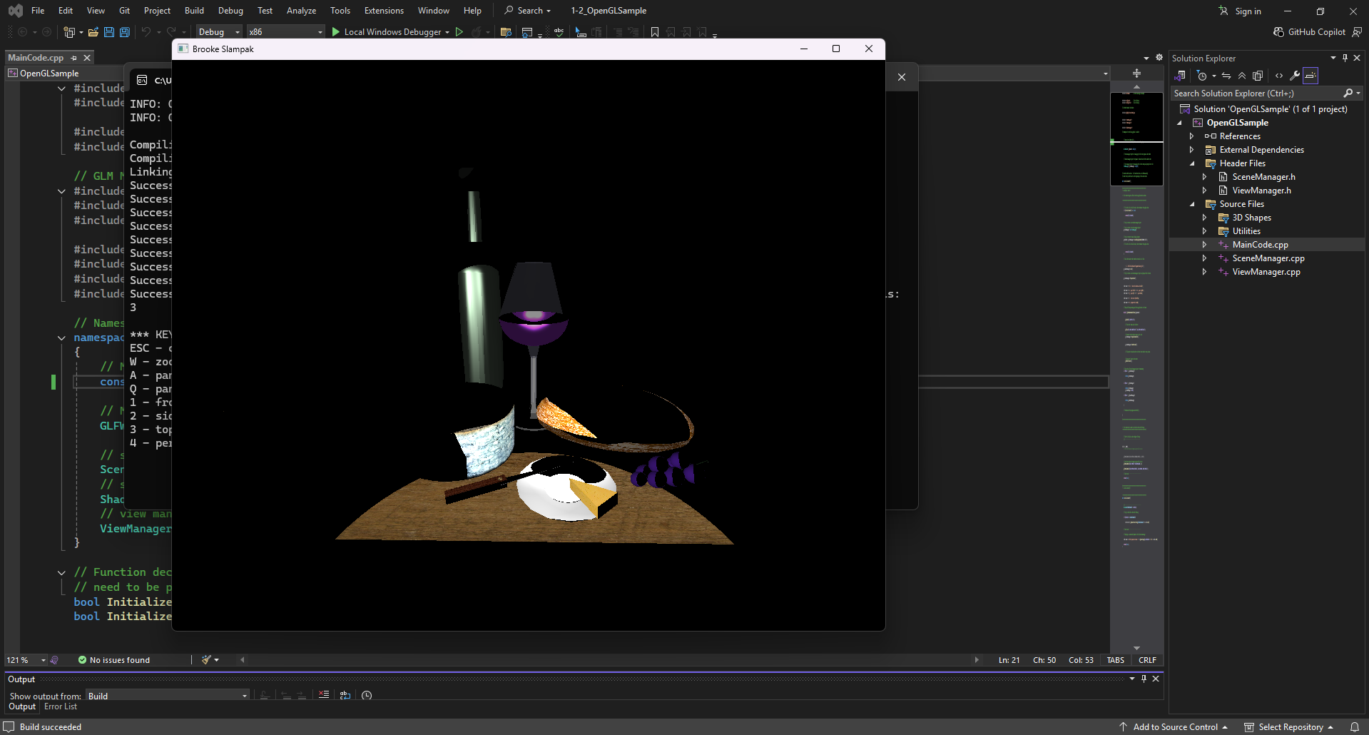

Since I have prior experience using Visual Studio from previous classes, I did not experience any significant challenges while setting up OpenGL. This made the setup process easy and straightforward, and I was able to follow the instructions without running into errors or missing components.
All the sample code provided compiled and ran as expected, and I did not encounter any issues. At this time, I do not have any questions or sections of the sample code that I was unable to run, but I will reach out if I encounter any issues as the project becomes more complex.

